Admin Pro job description

If currently filled and doing an update please fill in current person name:

Position Justification
Reason for Modification – if modification of position
Reason for Modification

Position Justification
Justification of Need
Is this position 100% gift or grant funded?
Is this position is a State Classified to Administrative Professional conversion
If this position is SC to AP conversion please provide the State Classified title, name of employee, and position number.
Source Funding

Classification Information
Classification Title
Classification Code

Position Information
Working Title
Position Number
Supervisor Email Address
Employment Category
Proposed Annual Salary Range
Salary Basis
FLSA
Department (Lory Student Center, Dining Services, Bookstore, SLiCE)
Description of Work Unit
Mission of Unit/Dept., who does this position report to?

Position Summary
Briefly describe the purpose of the position. (1 or 2 sentences) Why does this position exist? and/or What is the overall end result expected of this job? This is also the area to sell this position to applicants. (Please do not repeat the Job duties.)
Position Supervises
Does this position supervise other employees? How many, titles and position numbers? What is percentage of time involved performing supervisory duties?

Decision Making
Provide specific examples of decisions at the highest level of significance that are related to the Essential Job Duties of the position, are regular and on-going, do not require supervisory approval, and determine how the duties are performed. Does this position have authority to make decisions about aspects of their work? At what point are they required to request some type of approval? Do other positions elevate decisions to this position, if so what type of decisions?
Conditions of Employment
Required Job Qualifications
Education, Experience, Certifications, Licensing, other qualifications. Differentiate between required and preferred qualifications. Please list the professional field(s) associated with the work assignment.
Preferred Job Qualifications
Knowledge, Skills, and Abilities preferred but not mandatory
Hiring Authority
Is this an Hourly position?
Work Hours/Week

Action Verbs

The following action verbs and definitions can aid in writing effective position description essential duty statements:
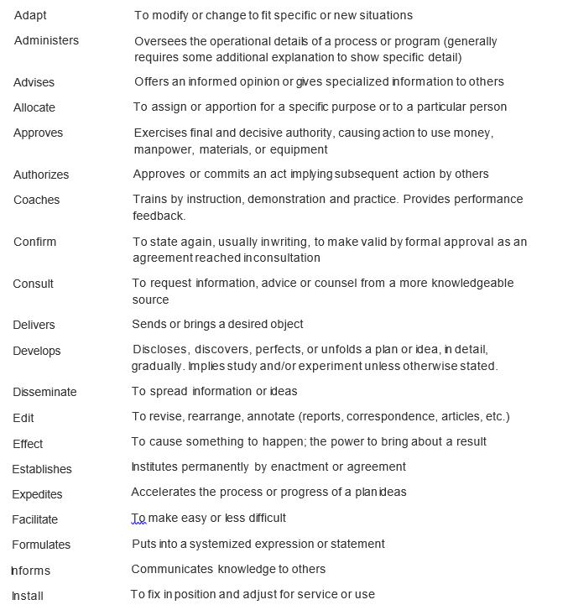
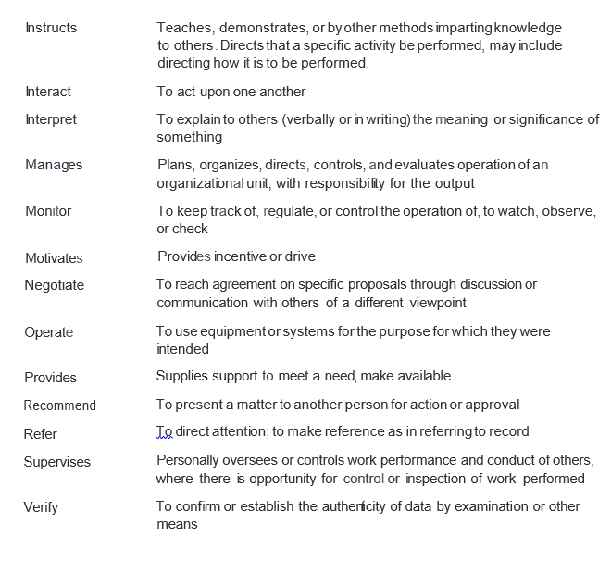

Essential Job Duties (A minimum of two Job Duties must be provided)
Tasks and responsibilities that are necessary in order to perform job

While writing your duties, remember to answer three things:
1. What is done? (action words) This conveys the act or work.
2. How is it done? This is where you describe the action or work. The “how” conveys the interaction with data, people or things.
3. Why is it done? (Purpose) The purpose or end result or effect.

Job Duty Category  E.g. Supervision, Accounting, Project Management, etc. | % of time | Duty/Responsibility

FUNCTIONAL ATTRIBUTES OF JOB DUTIES

I. PHYSICAL DEMANDS  A. SEDENTARY - Exert up to 10 lbs. of force occasionally and/or a negligible amount of force frequently or constantly to lift, carry, push, pull, or otherwise move objects, including the human body. Involves sitting most of the time, but may involve walking or standing for brief periods of time.  B. LIGHT - Exert up to 20 lbs. of force occasionally, and/or up to 10 lbs. of force frequently, and/or a negligible amount of force constantly to move objects. Physical demands are in excess of those of Sedentary work. Light work usually requires walking or standing to a significant degree.  C. MEDIUM - Exert up to 50 lbs. of force occasionally, and/or up to 20 lbs. of force frequently, and/or up to 10 lbs. of force constantly to move objects.  D. HEAVY - Exert up to 100 lbs. of force occasionally, and/or up to 50 lbs. of force frequently, and/or up to 20 lbs. of force constantly to move objects.  E. VERY HEAVY - Exert in excess of 100 lbs. of force occasionally, and/or in excess of 50 lbs. of force frequently, and/or in excess of 20 lbs. of force constantly to move objects.  1. CLIMBING - Ascending or descending using feet and legs and/or hands and arms. Body agility is emphasized.  2. BALANCING - Maintaining body equilibrium to prevent falling on narrow, slippery, or erratically moving surfaces; or maintaining body equilibrium when performing feats of agility.  3. STOOPING - Bending body downward and forward. This factor is important if it occurs to a considerable degree and requires full use of the lower extremities and back muscles.  4. KNEELING - Bending legs at knees to come to rest on knee or knees.  5. CROUCHING - Bending body downward and forward by bending legs and spine.  6. CRAWLING - Moving about on hands and knees or hands and feet.  7. REACHING - Extending hand(s) and arm(s) in any direction.  8. HANDLING - Seizing, holding, grasping, turning, or otherwise working with hand or hands. Fingers are involved only to the extent that they are an extension of the hand.  9. FINGERING - Picking, pinching, or otherwise working primarily with fingers rather than with the whole hand or arm as in handling.  10. FEELING - Perceiving attributes of objects, such as size, shape, temperature, or texture, by touching with skin, particularly that of fingertips.  11. TALKING - Expressing or exchanging ideas by means of the spoken word. Talking is important for those activities in which workers must impart oral information to clients or to the public, and in those activities in which they must convey detailed or important spoken instructions to other workers accurately, loudly, or quickly. | 12. HEARING - perceiving the nature of sounds. Used for those activities that require ability to receive detailed information through oral communication, and to make fine discriminations in sounds, such as when making fine adjustments on running engines.  13. TASTING/SMELLING - Distinguishing, with a degree of accuracy, differences, or similarities in intensity or quality of flavors and/or odors, or recognizing particular flavors and/or odors, using tongue and/or nose.  14. NEAR ACUITY - Clarity of vision at 20 inches or less. Use this factor when special and minute accuracy is demanded.  15. FAR ACUITY - Clarity of vision at 20 feet or more. Use this factor when visual efficiency in terms of far acuity is required in day and night/dark conditions.  16. DEPTH PERCEPTION - Three-dimensional vision. Ability to judge distances and spatial relationships so as to see objects where and as they actually are.  17. ACCOMMODATION - Adjustment of lens of eye to bring an object into sharp focus. Use this factor when requiring near point work at varying distances.  18. COLOR VISION - Ability to identify and distinguish colors.  19. FIELD OF VISION - Observing an area that can be seen up and down or to right or left while eyes are fixed on a given point. Use this factor when job performance requires seeing a large area while keeping the eyes fixed.  20. CONTROL OF OTHERS - seizing, holding, controlling, and/or otherwise subduing violent, assaultive, or physically threatening persons to defend oneself or prevent injury. Body strength and agility of all four limbs is necessary.  II. MENTAL FUNCTIONS  1. COMPARING - Judging the readily observable functional, structural, or compositional characteristics (whether similar to or divergent from obvious standards) of data, people, or things.  2. COPYING - Transcribing, entering, or posting data.  3. COMPUTING - Performing arithmetic operations and reporting on and/or carrying out a prescribed action in relation to them.  4. COMPILING - Gathering, collating, or classifying information about data, people, or things. Reporting and/or carrying out a prescribed action in relation to the evaluation is frequently involved.  5. ANALYZING - Examining and evaluating data. Presenting alternative actions in relation to the evaluation is frequently involved.  6. COORDINATING - Determining time, place, and sequence of operations or action to be taken on the basis of analysis of data. May include prioritizing multiple responsibilities and/or accomplishing them simultaneously.  7. SYNTHESIZING - To combine or integrate data to discover facts and/or develop knowledge or creative concepts and/or interpretations. | 8. NEGOTIATING - Exchanging ideas, information, and opinions with others to formulate policies and programs and/or jointly arrive at decisions, conclusions, solutions, or solve disputes.  9. COMMUNICATING - Talking with and/or listening to and/or signaling people to convey or exchange information, includes giving/receiving assignments and/or directions.  10. INSTRUCTING - Teaching subject matter to others, or training others through explanation, demonstration, and supervised practice; or making recommendations on the basis of technical disciplines.  11. INTERPERSONAL SKILLS/BEHAVIORS - Dealing with individuals with a range of moods and behaviors in a tactful, congenial, personal manner so as not to alienate or antagonize them.  III. ENVIRONMENTAL CONDITIONS & PHYSICAL SURROUNDINGS - exposure results in marked bodily discomfort.  1. EXPOSURE TO WEATHER - Exposure to hot, cold, wet, humid, or windy conditions caused by the weather.  2. EXTREME COLD - Exposure to nonweather-related cold temperatures.  3. EXTREME HEAT - Exposure to nonweather-related hot temperatures.  4. WET AND/OR HUMID - Contact with water or other liquids; or exposure to nonweather-related humid conditions.  5. NOISE - Exposure to constant or intermittent sounds or a pitch or level sufficient to cause mark ed distraction or possible hearing loss.  6. VIBRATION - Exposure to a shaking object or surface. This factor is rated important when vibration causes a strain on the body or extremities.  7. ATMOSPHERIC CONDITIONS - Exposure to conditions such as fumes, noxious odors, dusts, mists, gases, and poor ventilation, that affects the respiratory system, eyes or, the skin.  8. CONFINED/RESTRICTED WORKING ENVIRONMENT - Work is performed in a closed or locked facility providing safety and security for clients, inmates, or fellow workers.  IV. HAZARDS  1. Proximity to moving, mechanical parts.  2. Exposure to electrical shock.  3. Working in high, exposed places.  4. Exposure to radiant energy.  5. Working with explosives.  6. Exposure to toxic or caustic chemicals.

Functional Attributes
PHYSICAL DEMANDS
 | A. SEDENTARY - Exert up to 10 lbs. of force occasionally and/or a negligible amount of force frequently or constantly to lift, carry, push, pull, or otherwise move objects, including the human body. Involves sitting most of the time, but may involve walking or standing for brief periods of time. | B. LIGHT - Exert up to 20 lbs. of force occasionally, and/or up to 10 lbs. of force frequently, and/or a negligible amount of force constantly to move objects. Physical demands are in excess of those of Sedentary work. Light work usually requires walking or standing to a significant degree. | C. MEDIUM - Exert up to 50 lbs. of force occasionally, and/or up to 20 lbs. of force frequently, and/or up to 10 lbs. of force constantly to move objects. | D. HEAVY - Exert up to 100 lbs. of force occasionally, and/or up to 50 lbs. of force frequently, and/or up to 20 lbs. of force constantly to move objects. | E. VERY HEAVY - Exert in excess of 100 lbs. of force occasionally, and/or in excess of 50 lbs. of force frequently, and/or in excess of 20 lbs. of force constantly to move objects.
Exertion of Force
 | A. All of the time - (90% or more of the time) | M. Most of the time - (50% or more of the time) | S. Some of the time - (less than 50% of the time) | R Rarely - (less than 10% or less of the time) | N Never
Sitting
Standing
Climbing
Balancing
Stooping
Kneeling
Crouching
Crawling
Reaching
Handling
Fingering
Feeling
Talking
Hearing
Tasting/Smelling
Near Acuity (Close Vision)
Far Acuity (Far Vision)
Depth Perception
Adjust Focus
Color Vision
Field of Vision
Control of Others

Mental Functions | A. All of the time - (90% or more of the time) | M. Most of the time - (50% or more of the time) | S. Some of the time - (less than 50% of the time) | R Rarely - (less than 10% or less of the time) | N Never
Comparing
Copying
Computing
Compiling
Analyzing
Coordinating
Synthesizing
Negotiating
Communicating
Instructing
Interpersonal Skills/Behaviors
Environmental Conditions & Physical Surroundings | A. All of the time - (90% or more of the time) | M. Most of the time - (50% or more of the time) | S. Some of the time - (less than 50% of the time) | R Rarely - (less than 10% or less of the time) | N Never
Exposure to Weather
Extreme Cold
Extreme Heat
Wet and/or Humid
Noise
Vibration
Atmospheric Conditions
Confined/Restricted Working Environment

Hazards | A. All of the time - (90% or more of the time) | M. Most of the time - (50% or more of the time) | S. Some of the time - (less than 50% of the time) | R Rarely - (less than 10% or less of the time) | N Never
Proximity to moving, mechanical parts
Exposure to electrical shock
Working in high, exposed places
Exposure to radiant energy
Working with explosives
Exposure to toxic or caustic chemicals
Exposure to poisonous or infectious materials

Background Check Requirement
 | Yes | No
Education Check: Is an educational degree check desired?
Financial History Check: does the position reside in Student Financial Services
Motor Vehicle Record Check: does the position require operation of university owned vehicle (regardless of frequency)?
Motor Vehicle Record Check: does the position require driving a motor vehicle (i.e. personal, rental) on a routine basis to conduct university business?
Motor Vehicle Record Check: does the position require a commercial driver's license?
Motor Vehicle Record Check: does the position require a three (3) year re-check?
Sensitive Conditions Check: does the position work with vulnerable populations (i.e. children, minors, animals etc.)
Sensitive Conditions Check: does the position work with controlled substances, select agents, or other sensitive research material/information?
Sensitive Conditions Check: does the position have unsupervised access to buildings, residence halls, or other secure facilities?
Sensitive Information Check: does the position have access to sensitive information?

Supervisor
Job Title
Position Number
Org Unit
First Name
Last Name
Email

